Introduction to Section 3: Fungal Pathogens affecting Cannabis

Since the Wassons introduced the term, the public consciousness in the United States and other ‘mycophobic’ cultures have grown to acknowledge and appreciate the myriad fungi in our world that benefit us as humans and make our lives better (Wasson and Wasson, 1957). However, even today many farmers, as with humans generally, are blissfully unaware of the fungi all around them until one or more fungi impose a problem upon them. This section will focus on these scourges of cultivators -fungi capable of infecting and directly causing disease among Cannabis. Thus, many species mentioned will be household names to you already. Even so, some diseases, like ‘budrot,’ may actually comprise numerous pathogens causing similar disease symptoms. While the well known Botrytis may cause the majority of budrot experienced by Cannabis cultivators, species of Aspergillus, Penicillium, and Sclerotinia may all cause morphologically similar damage and disease on Cannabis.
Chapters in this section are organized by disease category (i.e. powder mildews, budrot, damping off, vascular wilt, ect.). Plant diseases are classified by the symptoms that plants express when infected with the pathogen, whether it be fungal, bacterial, or virus. Species capable of causing each disease presentation are listed in tables within the chapter, focusing on common and emergent pathogens.
Diseases caused by fungal pathogens can also be grouped by what part of the plant the fungus attacks. Broadly speaking there are foliar-infecting fungi, stem-infecting fungi (vascular wilts), root-infecting fungi can cause crown rot or significantly decrease root mass, and finally flower-infecting fungi which grow on the inflorescences of mature Cannabis crops (Punja 202).

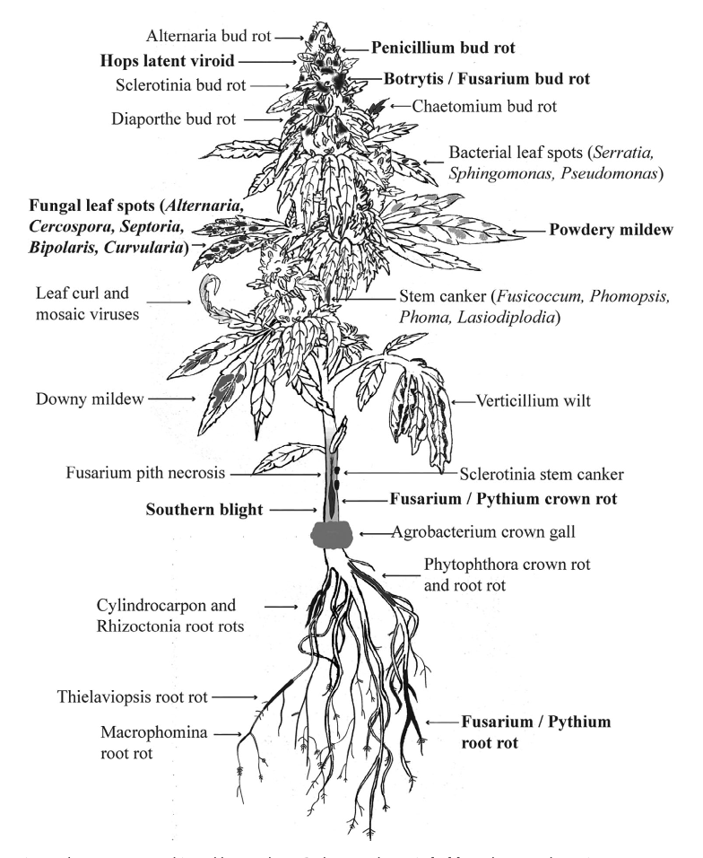
Figure 1. Anatomy of a flowering Cannabis plant and fungal diseases that infect different plant parts. (Punja 2021)

As Cannabis emerges as a mainstream crop in today's world, so does the science about its symbionts. Many pathogens remain undescribed and unknown to science even if individual farmers have already experienced them personally (HLVd was known as ‘dudding’ colloquially long before the viroid was known to exist). The United States Department of Agriculture, Agricultural Research Station maintains an excellent, up-to-date database of known fungal pathogens of Cannabis (and putatively any plant or fungal species for which information has been published).
Each chapter discusses the lifecycles and pathogen management options for causative species under different cultivation circumstances. Cannabis is incredibly diverse, as are the cultures and farmers who produce it. This is undeniably true for Cannabis in ways beyond any other crop. Farmers that are scaling up should lean on tried and true methods from traditional farmers that work at a field and farm level. Cultivators on a small scale have options open to no one else, particularly those growing indoors.

Section 3 Introduction Table 1. Disease Cannabis plants are susceptible to at different stages of the plants’ life cycle. X indicates the plants are susceptible, XX indicates the disease is regularly seen at that life stage and XXX indicates it is extremely common to see these fungal diseases at that stage of plant growth.
Stage of plant growth | Powdery Mildew | Bud rot | Damping off | Crown Rot | Canker | Leaf Spot
Cutting/seedling | X |  | XX |  |  | X
Vegetative | XX |  |  | XX | X | XX
Reproductive | XXX | XXX |  | XX | XX | XX
Post-harvest |  | XXX

